|  |  |  |  |  |  |
| --- | --- | --- | --- | --- | --- |
| Date | Sept 21, 2022 | | | Tester Name | Alyssa Johnson |
| Environment | Penfax - Test | | | Login used |  |
| Operating System | Select OS | Version: | Update: | | |
| Software Used | Select Software | Version: | Update: | | |
| Select Software | Version: | Update: | | |
| Release version | 22.3.0 | | | | |
| Title |  | | | | |
| Test Type | Regression | | | | |
| Test Scenario |  | | | | |
|  |  | | | | |
| Expected Results | Describe your steps with screenshots:   |  | | --- | | Navigate to Tax Slip Production -> Add Tax Slip Batch | | Create a T4A tax slip batch for:  - Plan = PEPP  - Report Type = Original  - Tax Year = Current Year | | * Verify that the Tax Slip batch ran successfully * Verify that individual T4A PDFs were created for each member & they can be opened. * Verify that a single XML extract was generated * Verify that a single PDF file for all T4As was generated * Verify that tax slip generated in tax slip portion of Penfax & matches slip * Confirm that only PEPP members show on the report (no MEPP or Pensioner services) * Verify that withdrawal amounts in Benefit Recipient and taxation amounts reflect what is reported on the T4A slip for several members * Confirm tax rates are correct * Check Members PENWEB to ensure they are visible, can be opened, match the Penfax slip and named correctly | | | | | |
| Pass/Fail | Pass | | | JIRA# | N/A |

Scheduled batch for early morning

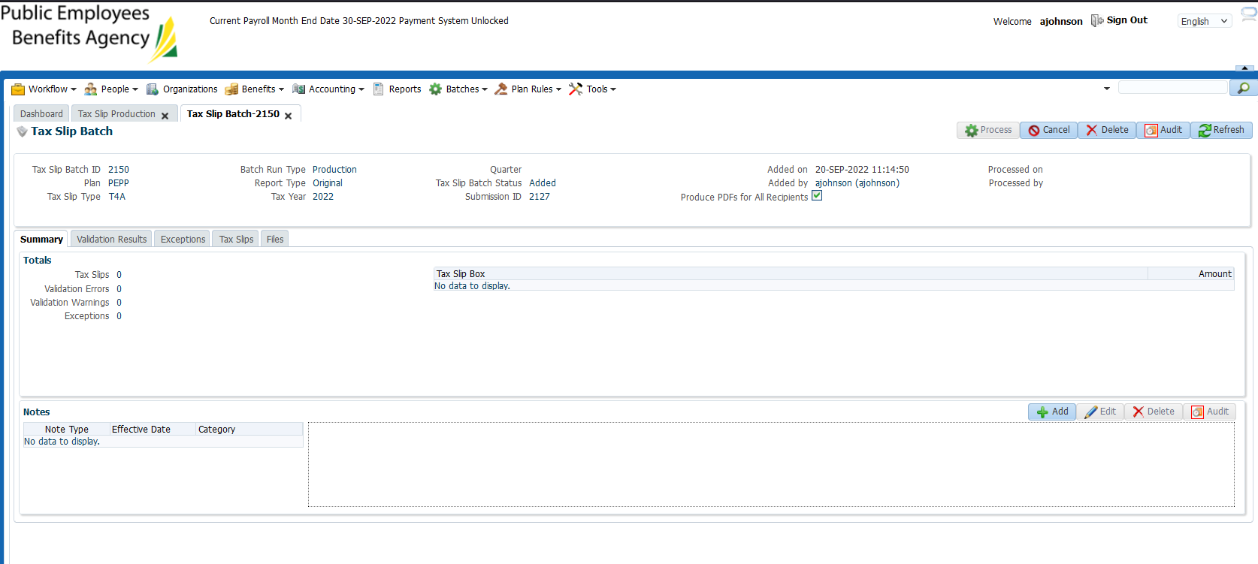

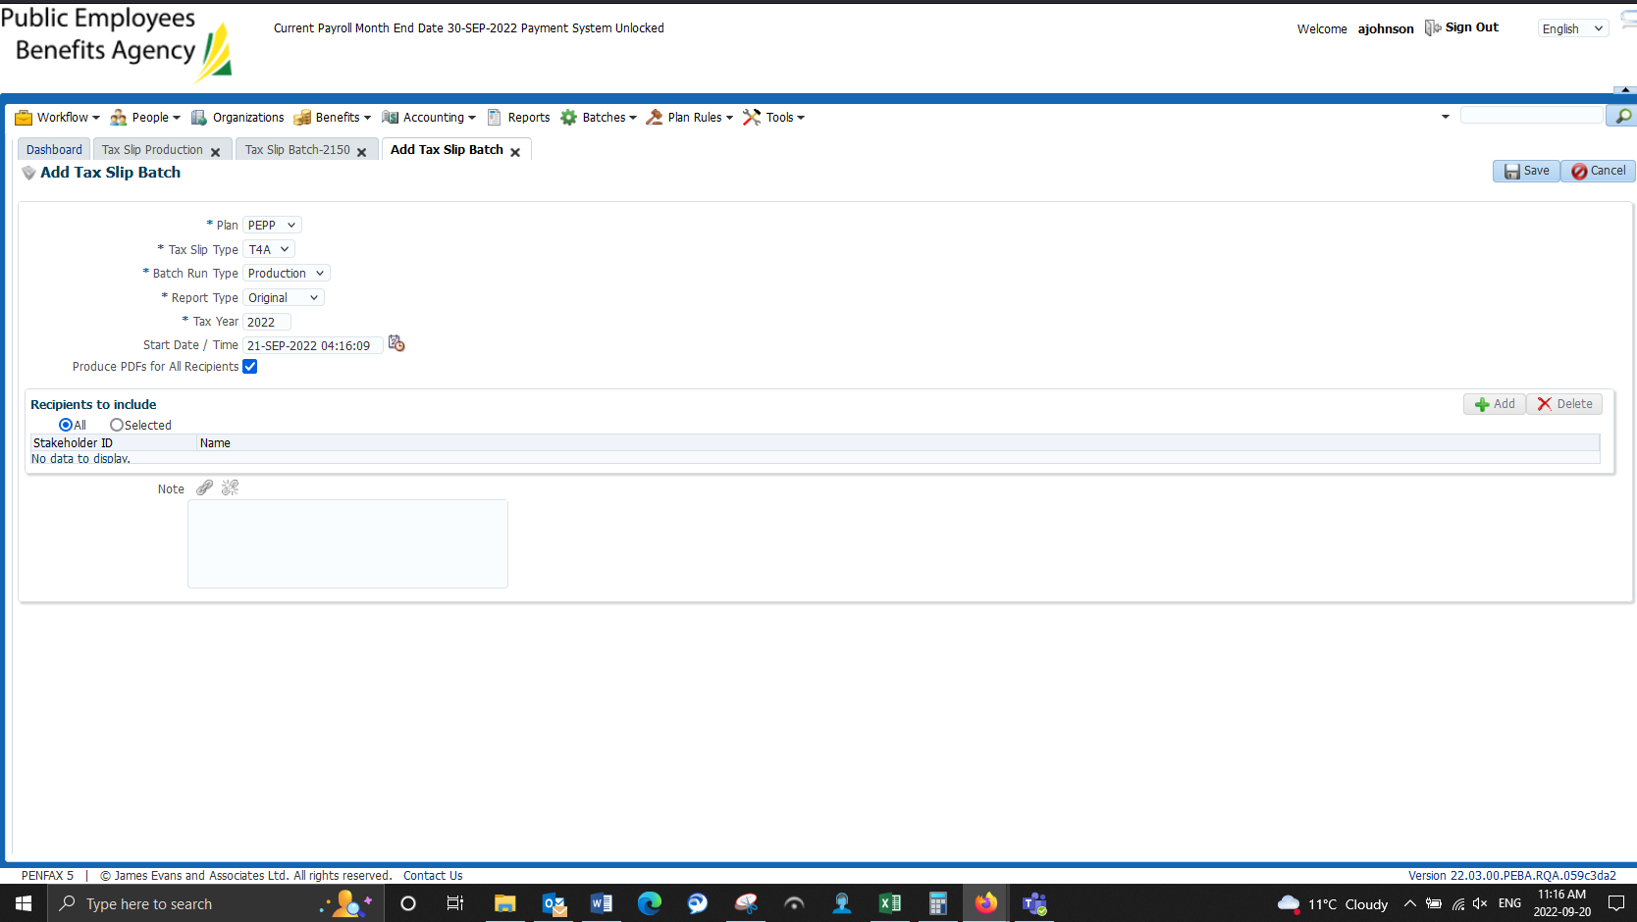

Wait until tomorrow to view.

Batch failed, death payment to charity:

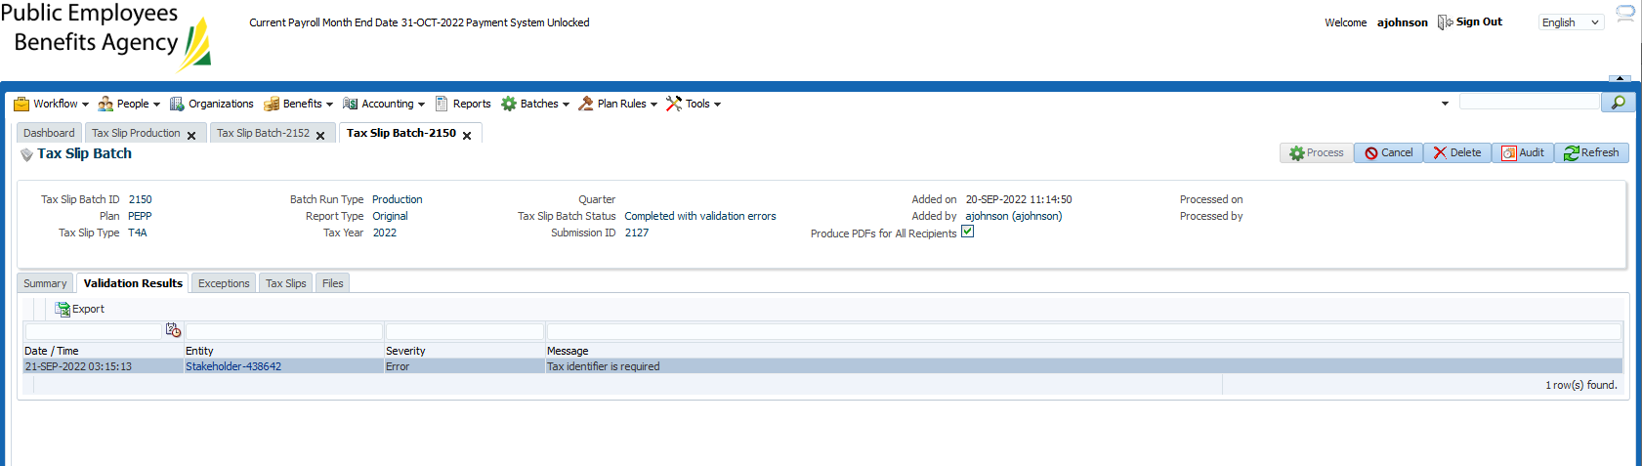

Spoke to Jordan, suggested to add an “Old ID” to the member’s person profile under Identity.

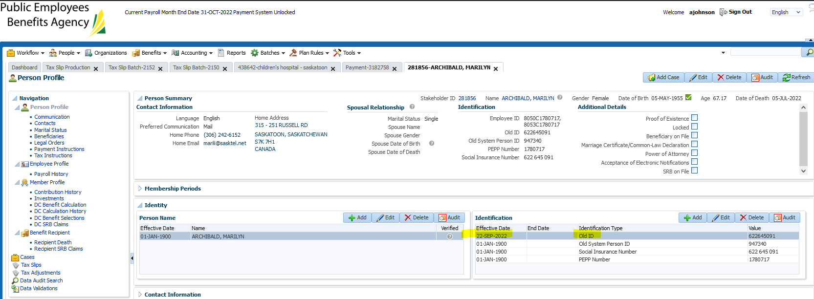

Death payment to charity was reversed Sept 22, 2022

Re-ran T4A batch & completed successfully.

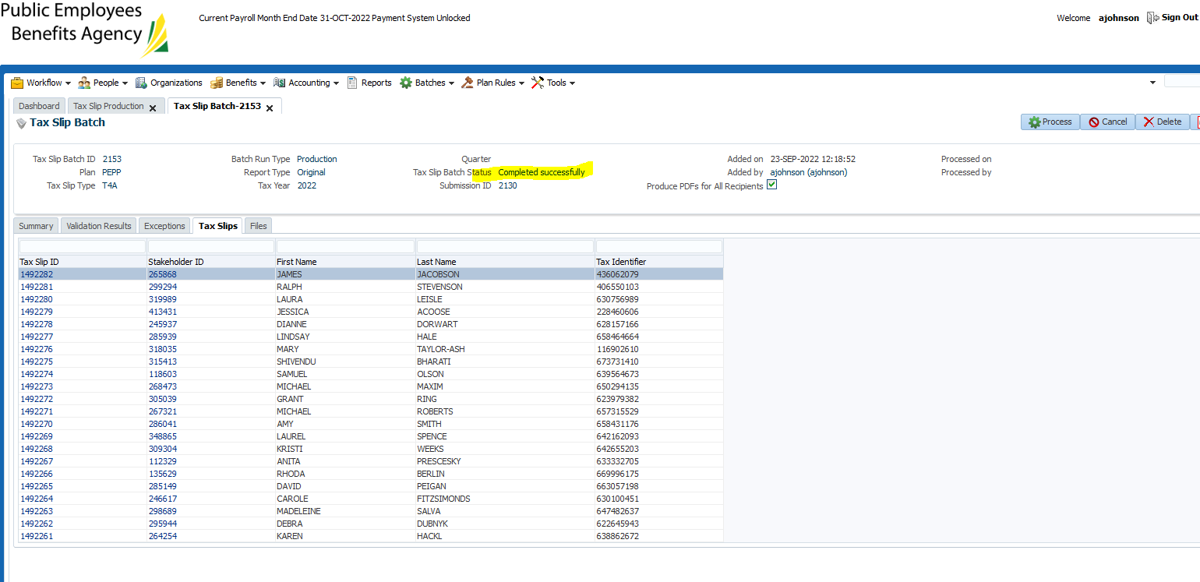

Confirmed that there are individual PDF’s, a master PDF and a master Xml file. They all open.

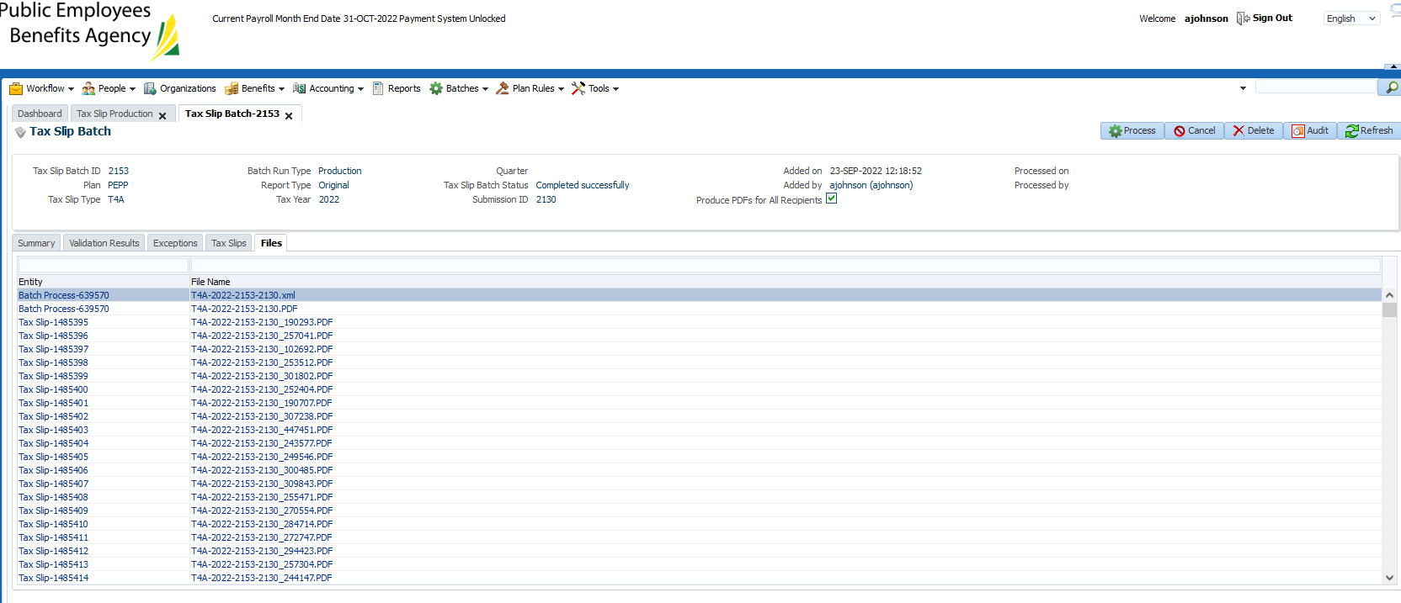

6888 T4A’s were generated.

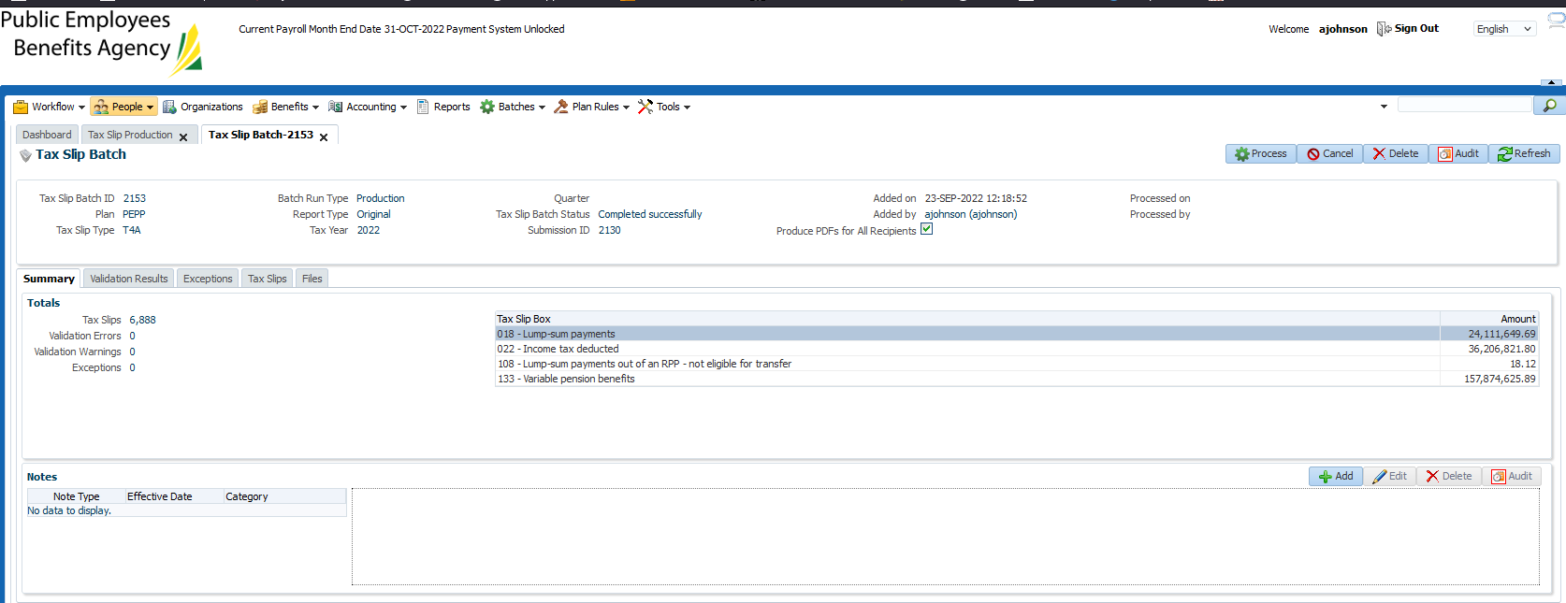

Checking a few members for calculation, showing under tax slips, showing under communications & visable in PENWEB:

SID 319989

No document in communications tab:

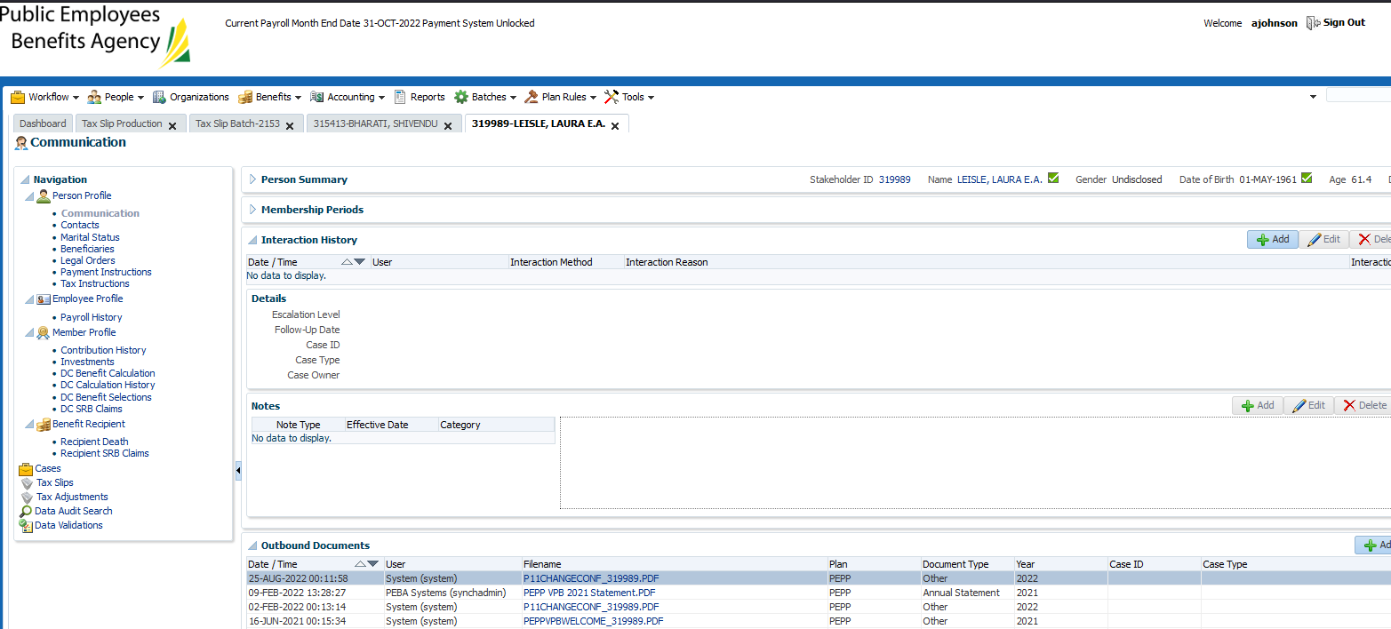

No tax slip created:

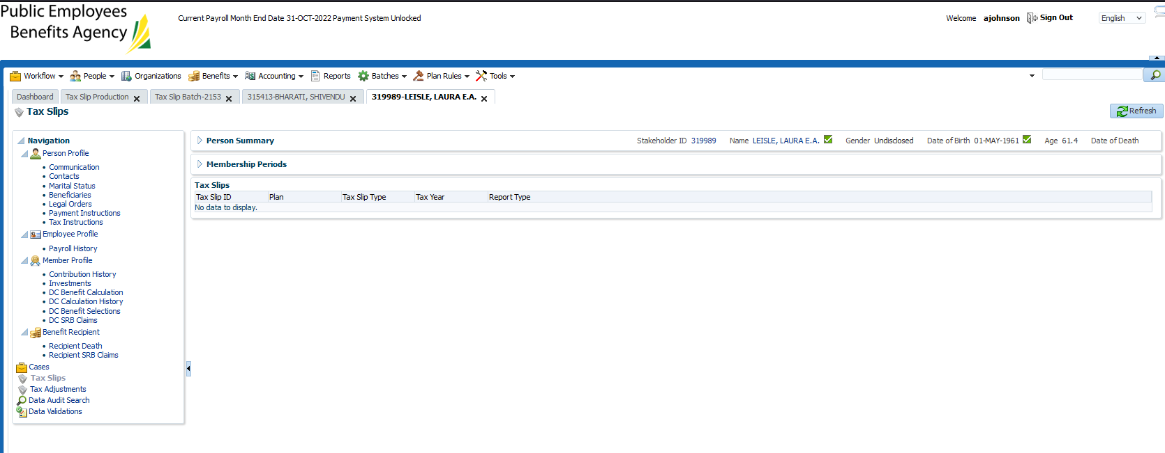

Realized I forgot a step & didn’t press process:

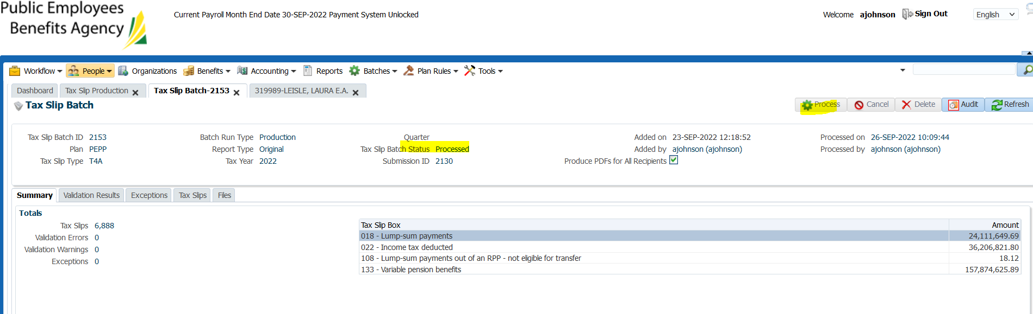

Once process was hit, checked accounts to confirm T4A is visible:

SID: 319989

Went into members communications tab to view T4A

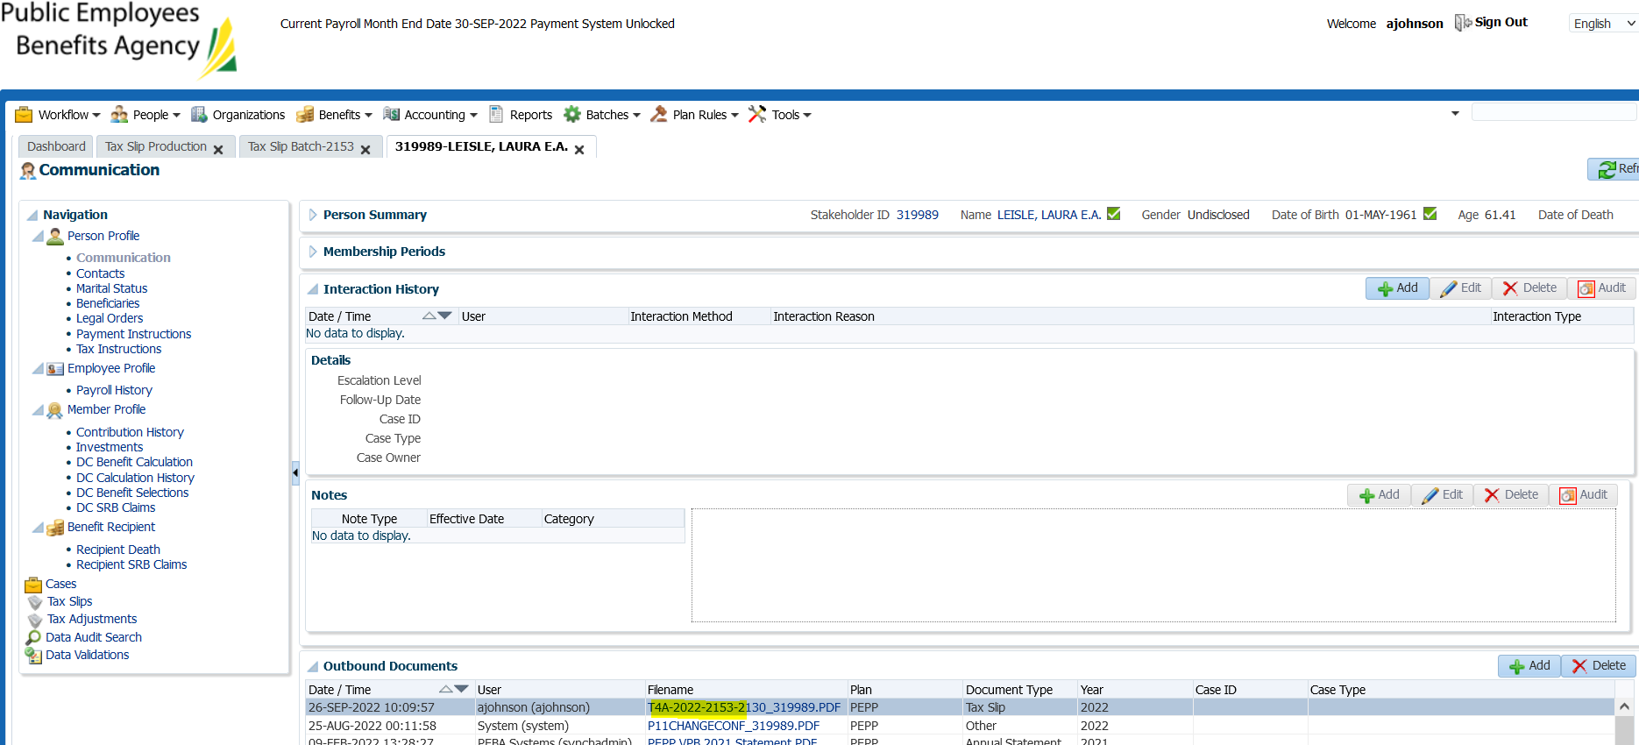

Signed into PlaNet admin portal & viewed on support mode

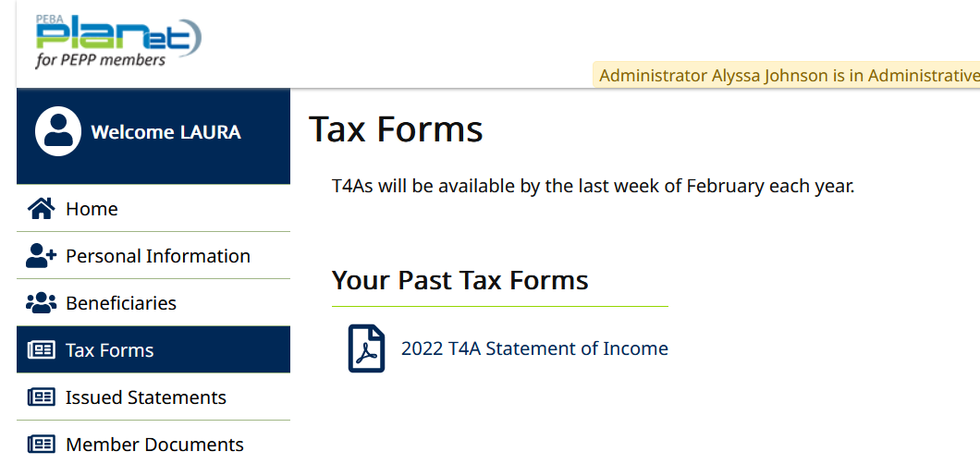

Clicked on tax slips, then the tax slip ID to view information:

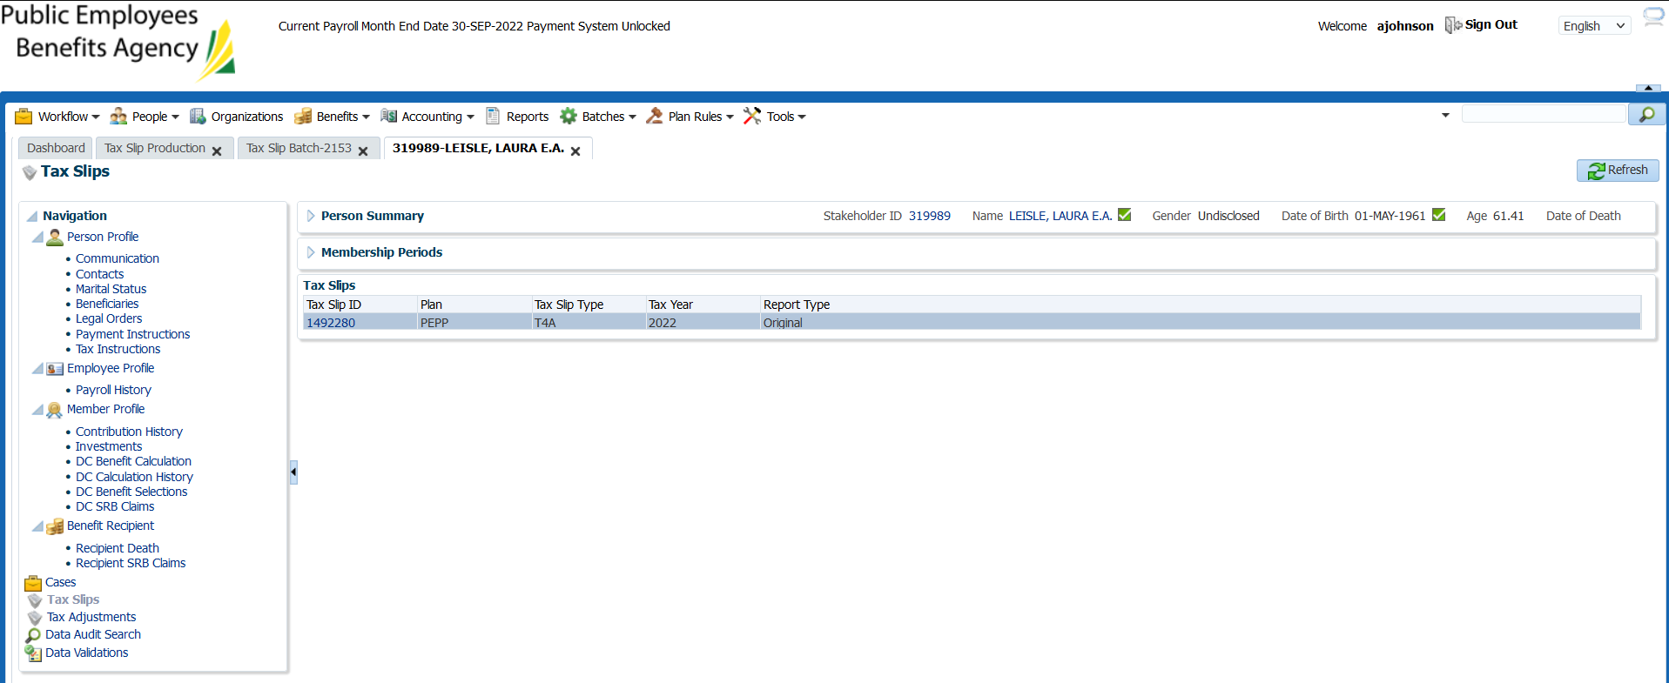

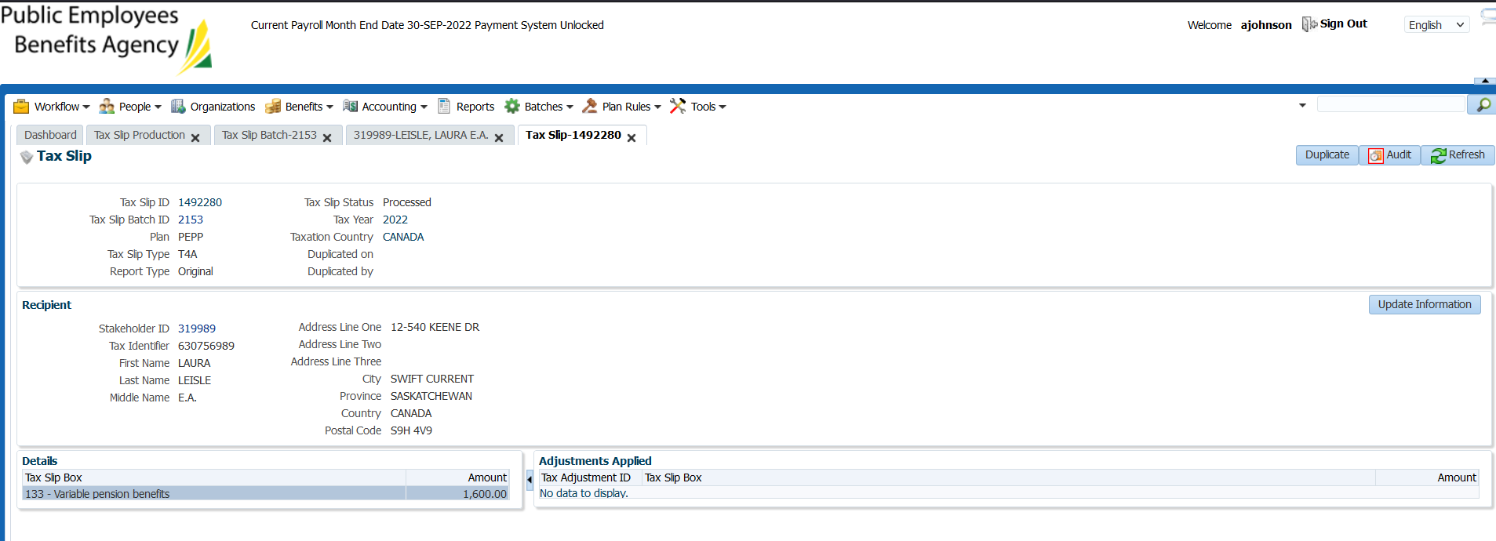

Confirm the tax slip is able to open & the amount of tax withheld matches benefit recipient:

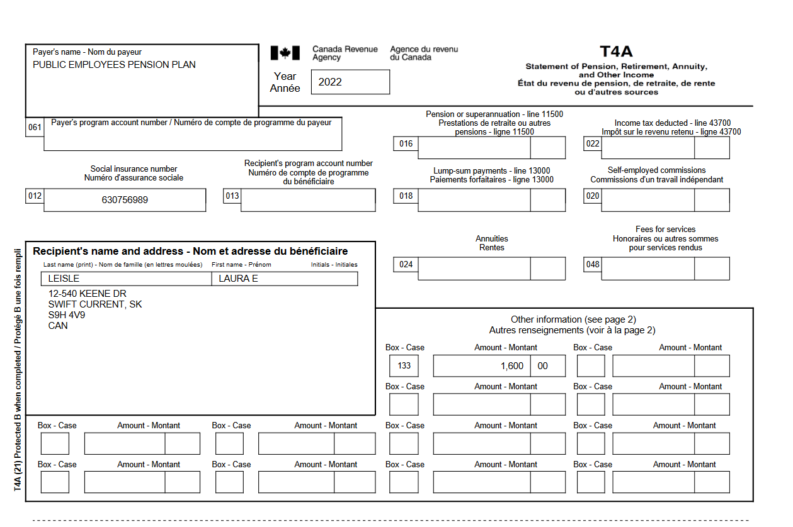

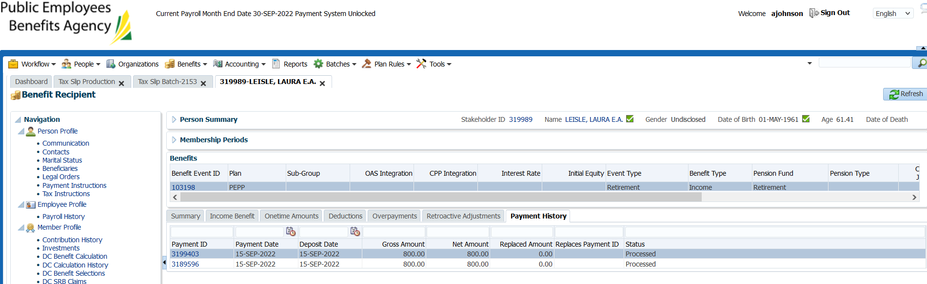

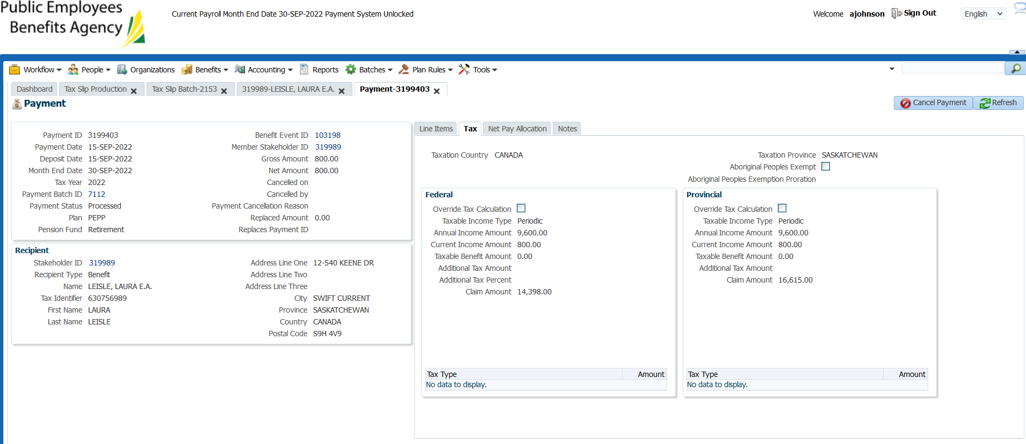

SID: 295085

Confirmed can view and open slip in communications tab:

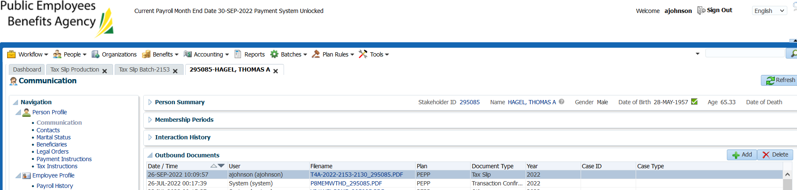

Verify the amount of tax withheld is correct:

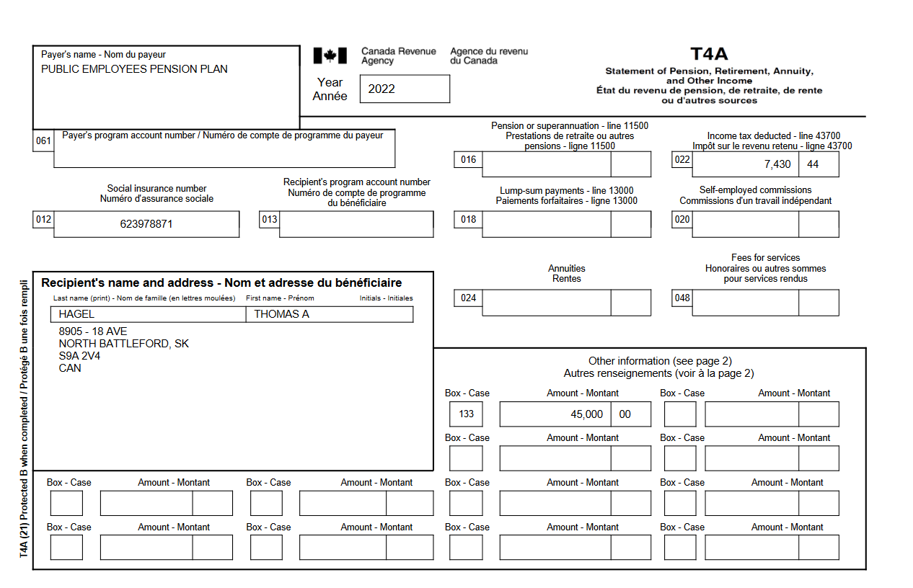

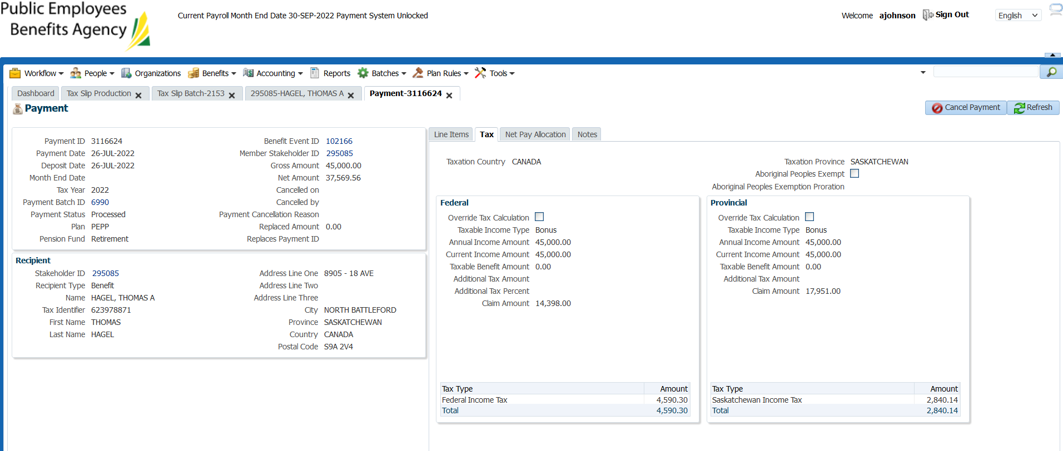

The amount on Penfax matches the amount “withheld” on the T4 slip.

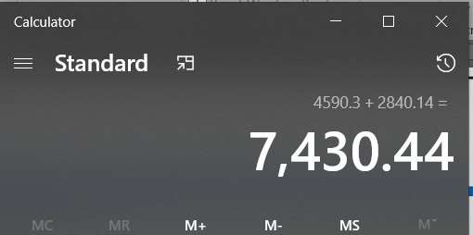

Verified tax withheld is correct (no scheduled payments, lump sum only):

45k/12=3750

*Note: Works if there is only 1 lump sum or for scheduled payments that are consistent through the year only, for multiple lump sum’s this calculator doesn’t work.*

<https://www.canada.ca/en/revenue-agency/services/e-services/e-services-businesses/payroll-deductions-online-calculator.html>

